

**FPT ACADEMY INTERNATIONAL**

**FPT – APTECH COMPUTER EDUCATION**

**INSTALLATION GUIDE FOR RHYTHM HOUSE WEBSITE**

**I. System Requirement**

|  |  |  |
| --- | --- | --- |
| **No** | **Software** | **Description** |
| **1** | **Operating system** | **Windows 7 or higher** |
| **2** | **Hardware** | **Intel Pentium 4 processor or higher**  **512 Megabytes of RAM or higher** |
| **3** | **Software** | **Visual Studio Code, Dreamweaver** |
| **4** | **Web browser** | **Internet Explorer 11 , Chrome, Firefox** |

1. **Introduction and website installation**

- This installation guide is create for guiding to use our website – Rhythm House in a effective way. Now should this before using website in practice.

- To run*Rhythm House* website, users need to do the following steps:

* + - 1. Download the file rar *eProject–Rhythm-House-by-Group-4* via this link: <https://github.com/imduyan/eProject>

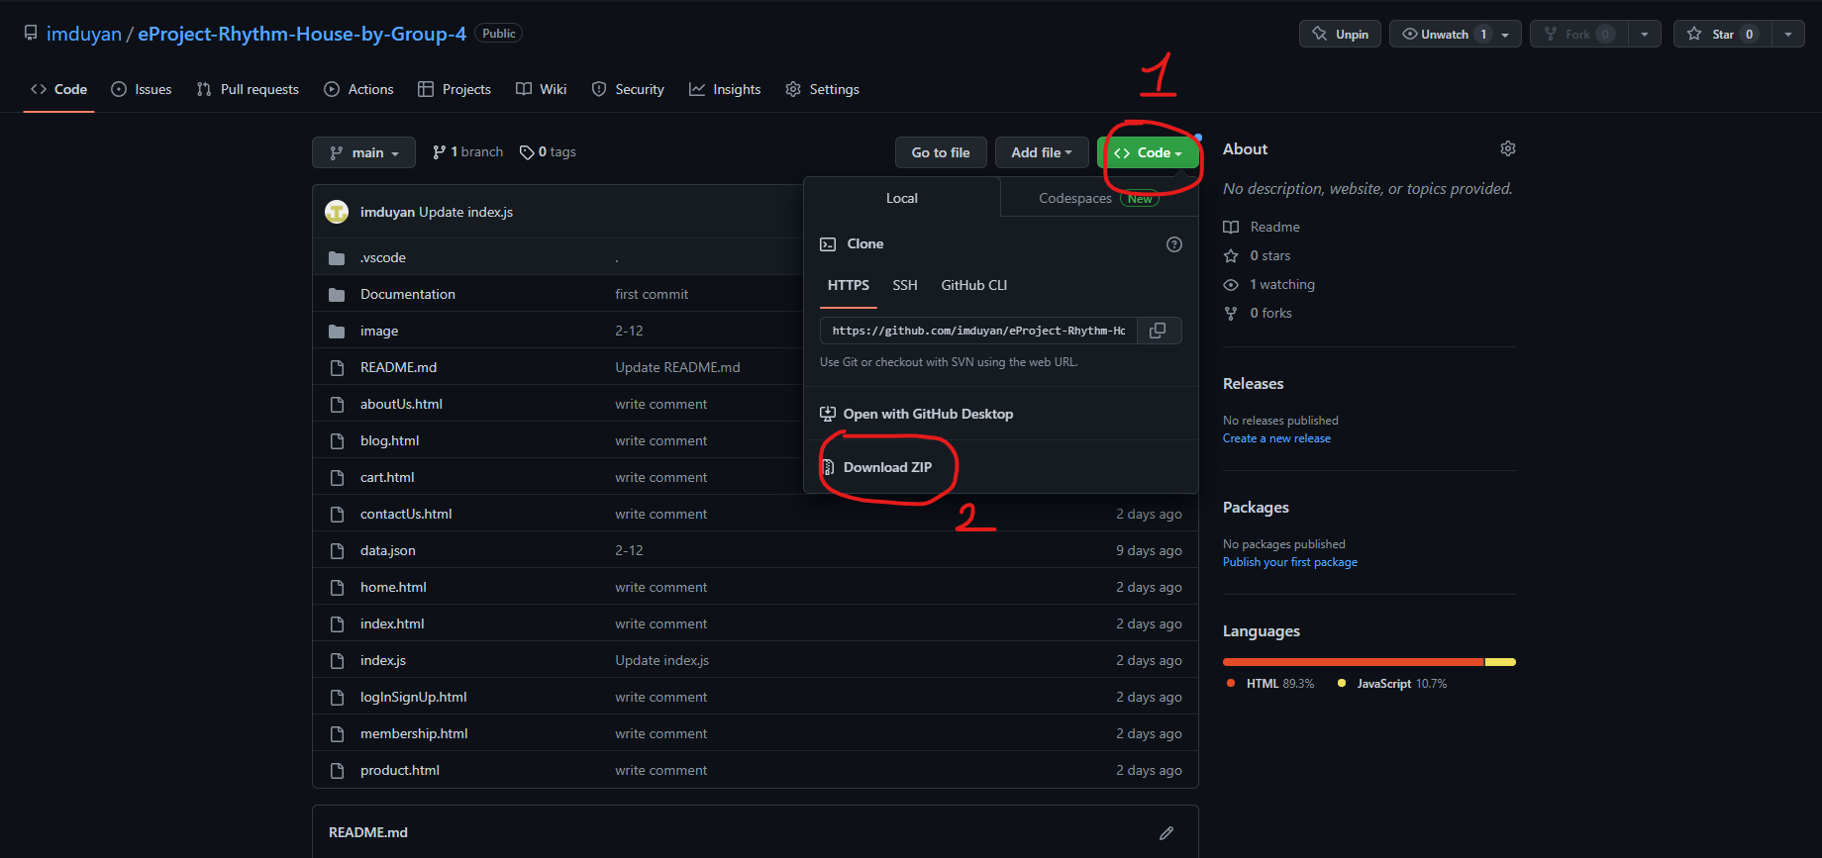

* + - 1. Extract the file rar: *eProject–Rhythm-House-by-Group-4-main* and then double click on the folder extracted

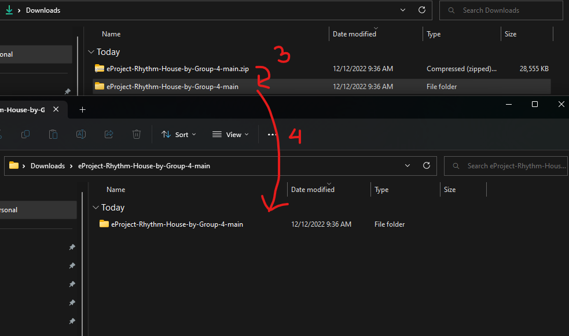

1. Open the folder with VS Code

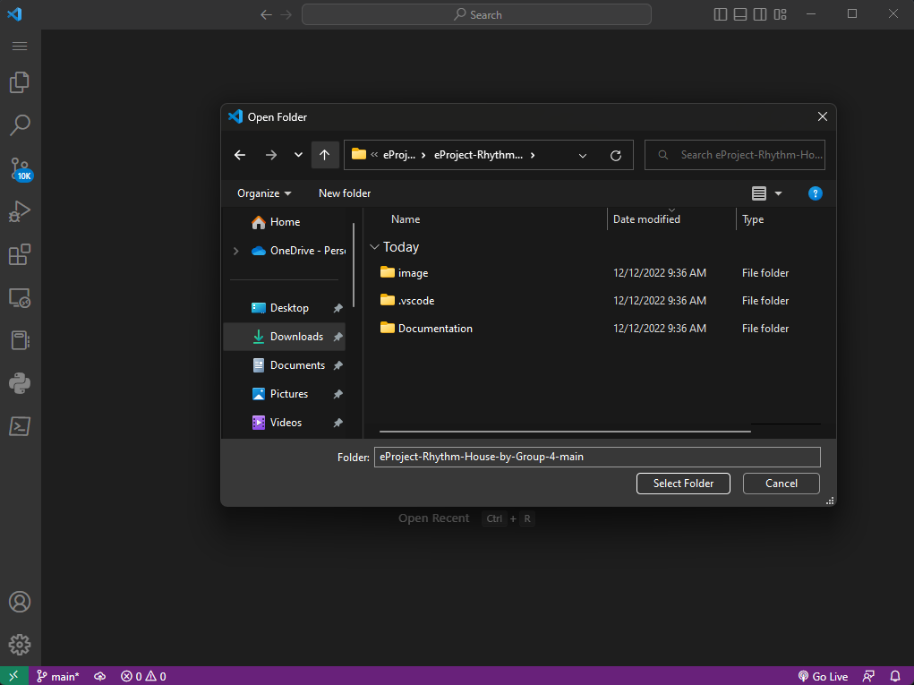

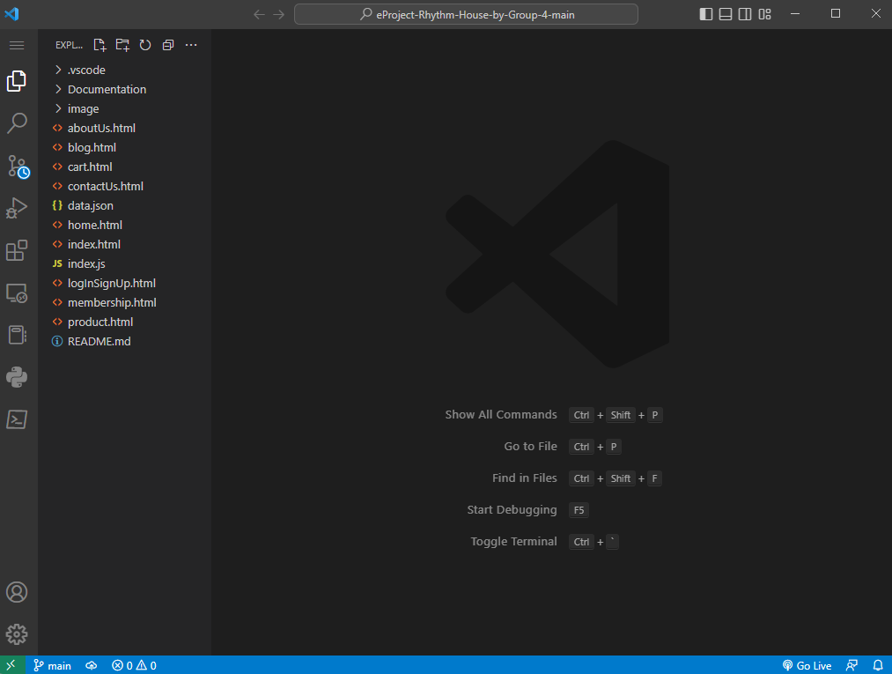

1. Right mouse on index.html then click open with live server

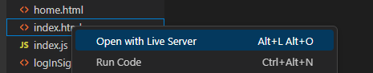

1. If done successfully, users will see the index page like figure 1 below

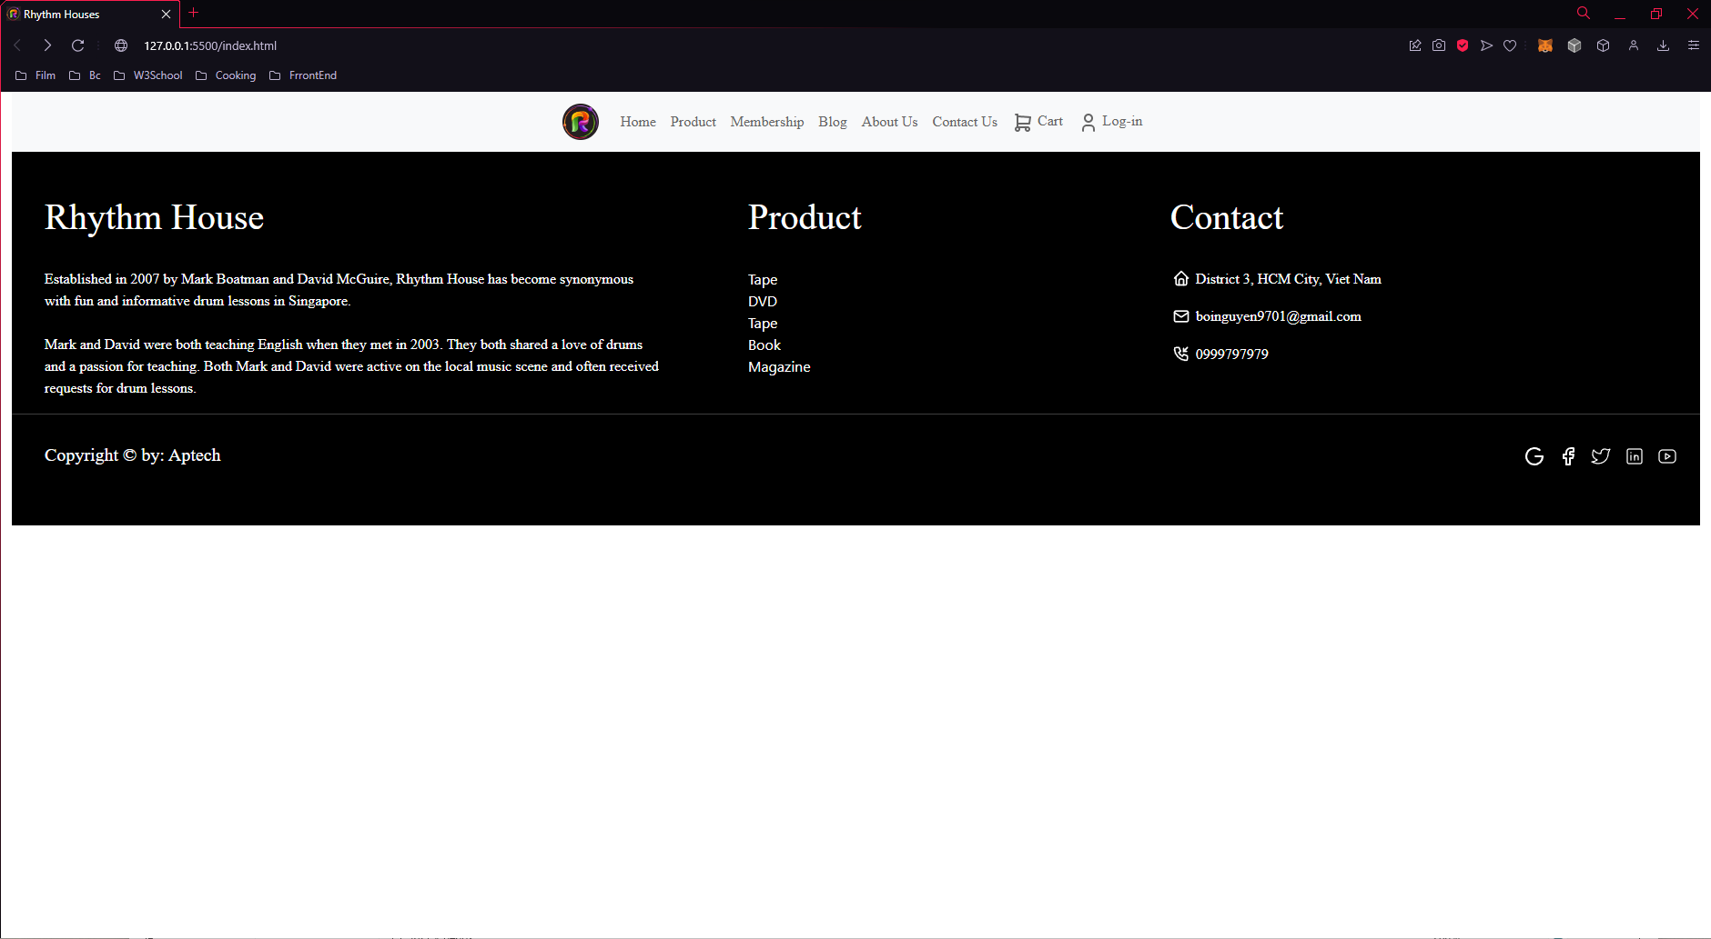

*Figure 1*

1. You can click on **home** or **logo** () to start using our website

*Figure 2*

1. Home Page

You can see some picture slide at the first. When you scroll down, some interesting thing will appear! Let’s try to know what it is 😊

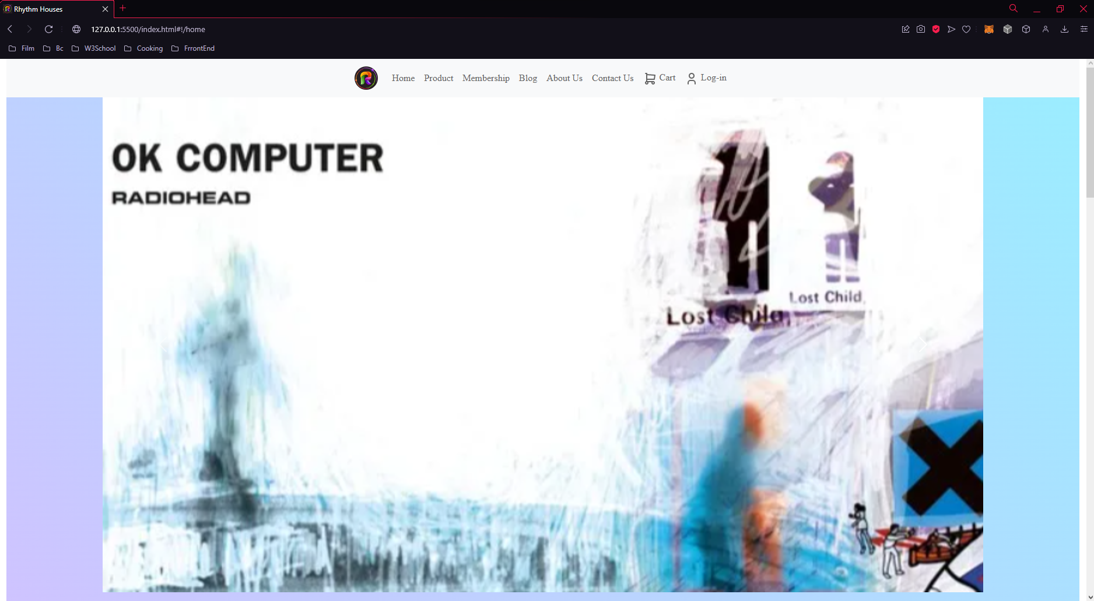

*Figure 2*

1. Product Page

In Product page, you can see our product, We also provide some services for searching product.

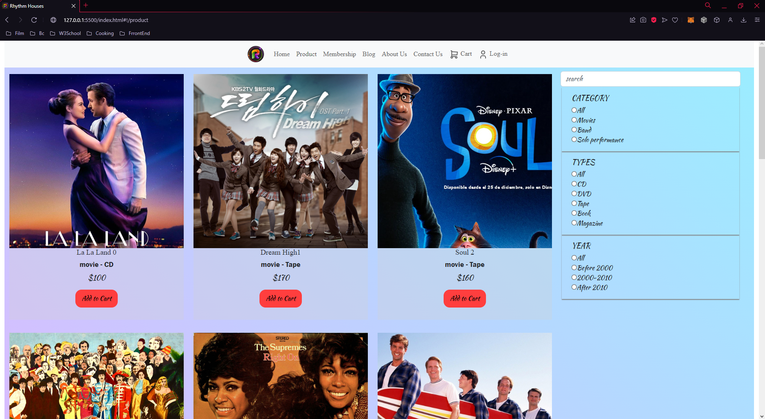

*Figure 3*

1. Memership Page

We provide a point calculation for you.

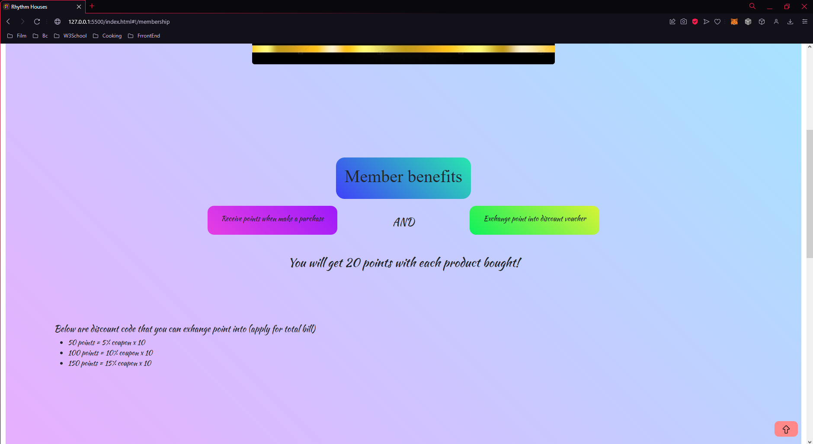

*Figure 4*

1. Blog Page

Blog page has 2 live shows and 2 contests

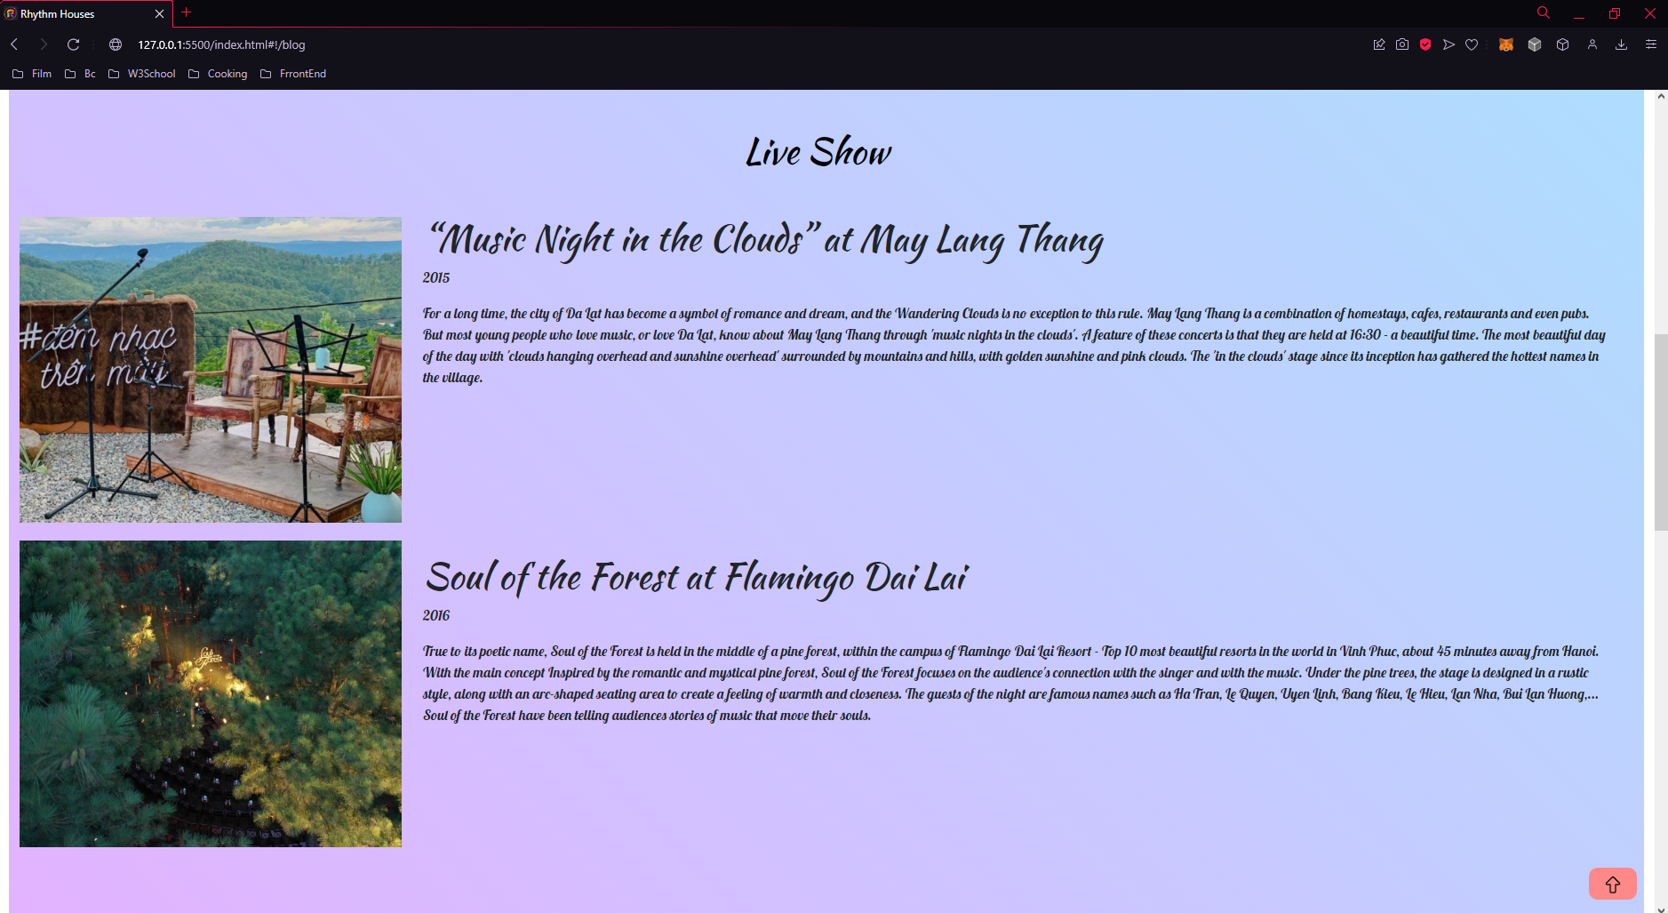

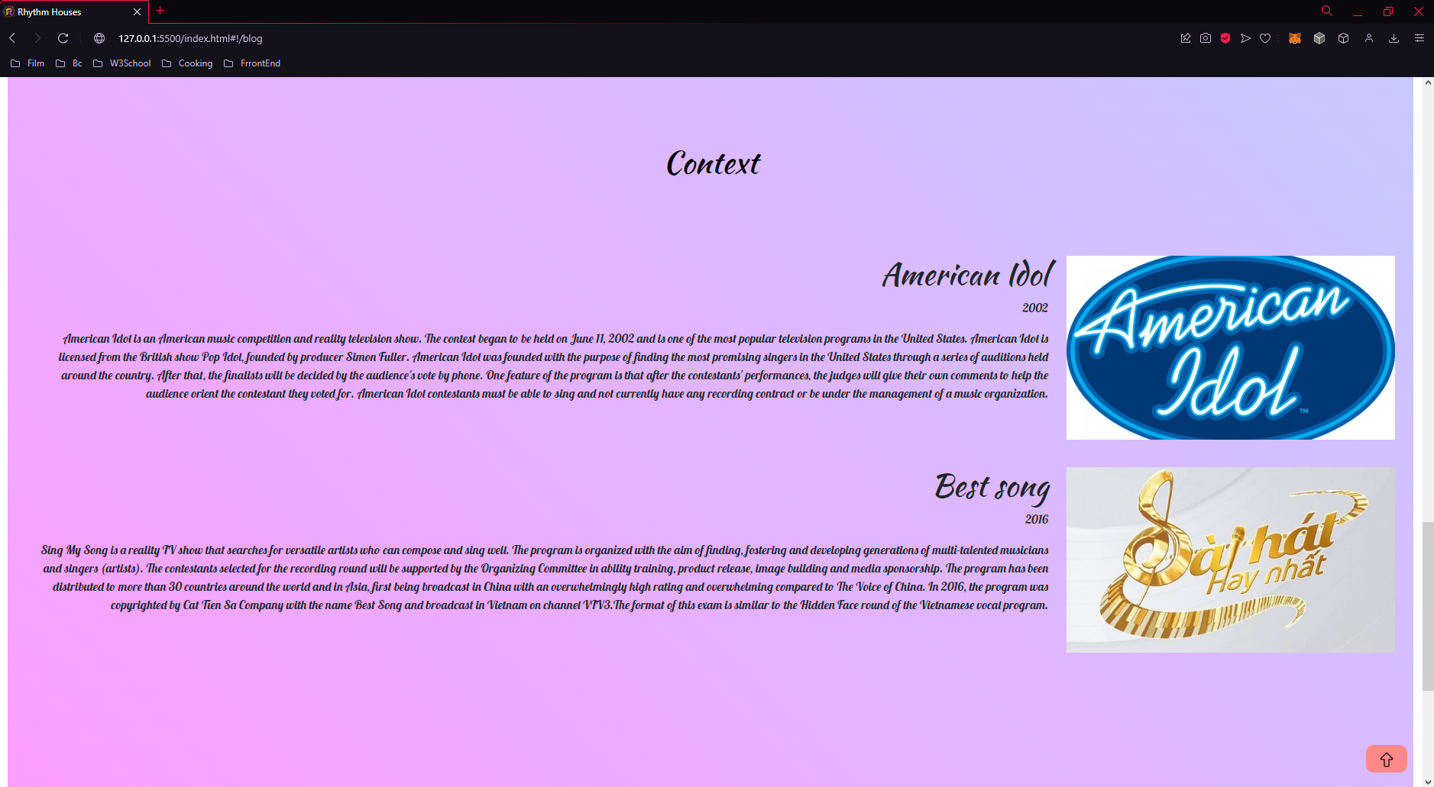

*Figure 5*

1. About Us Page

This page just has some basic information about rhythm house and teammember.

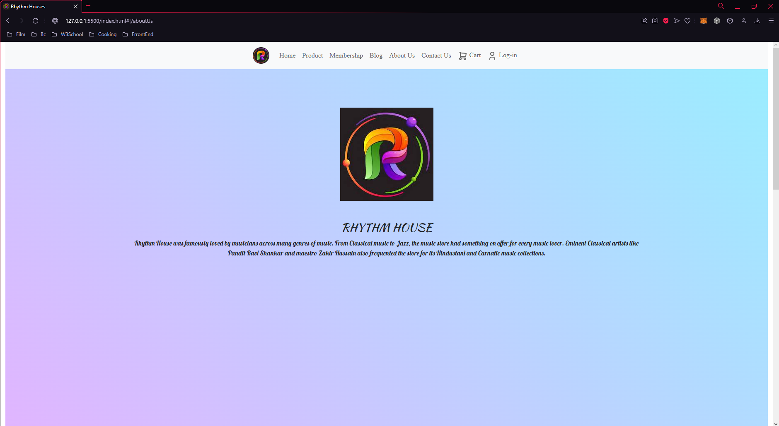

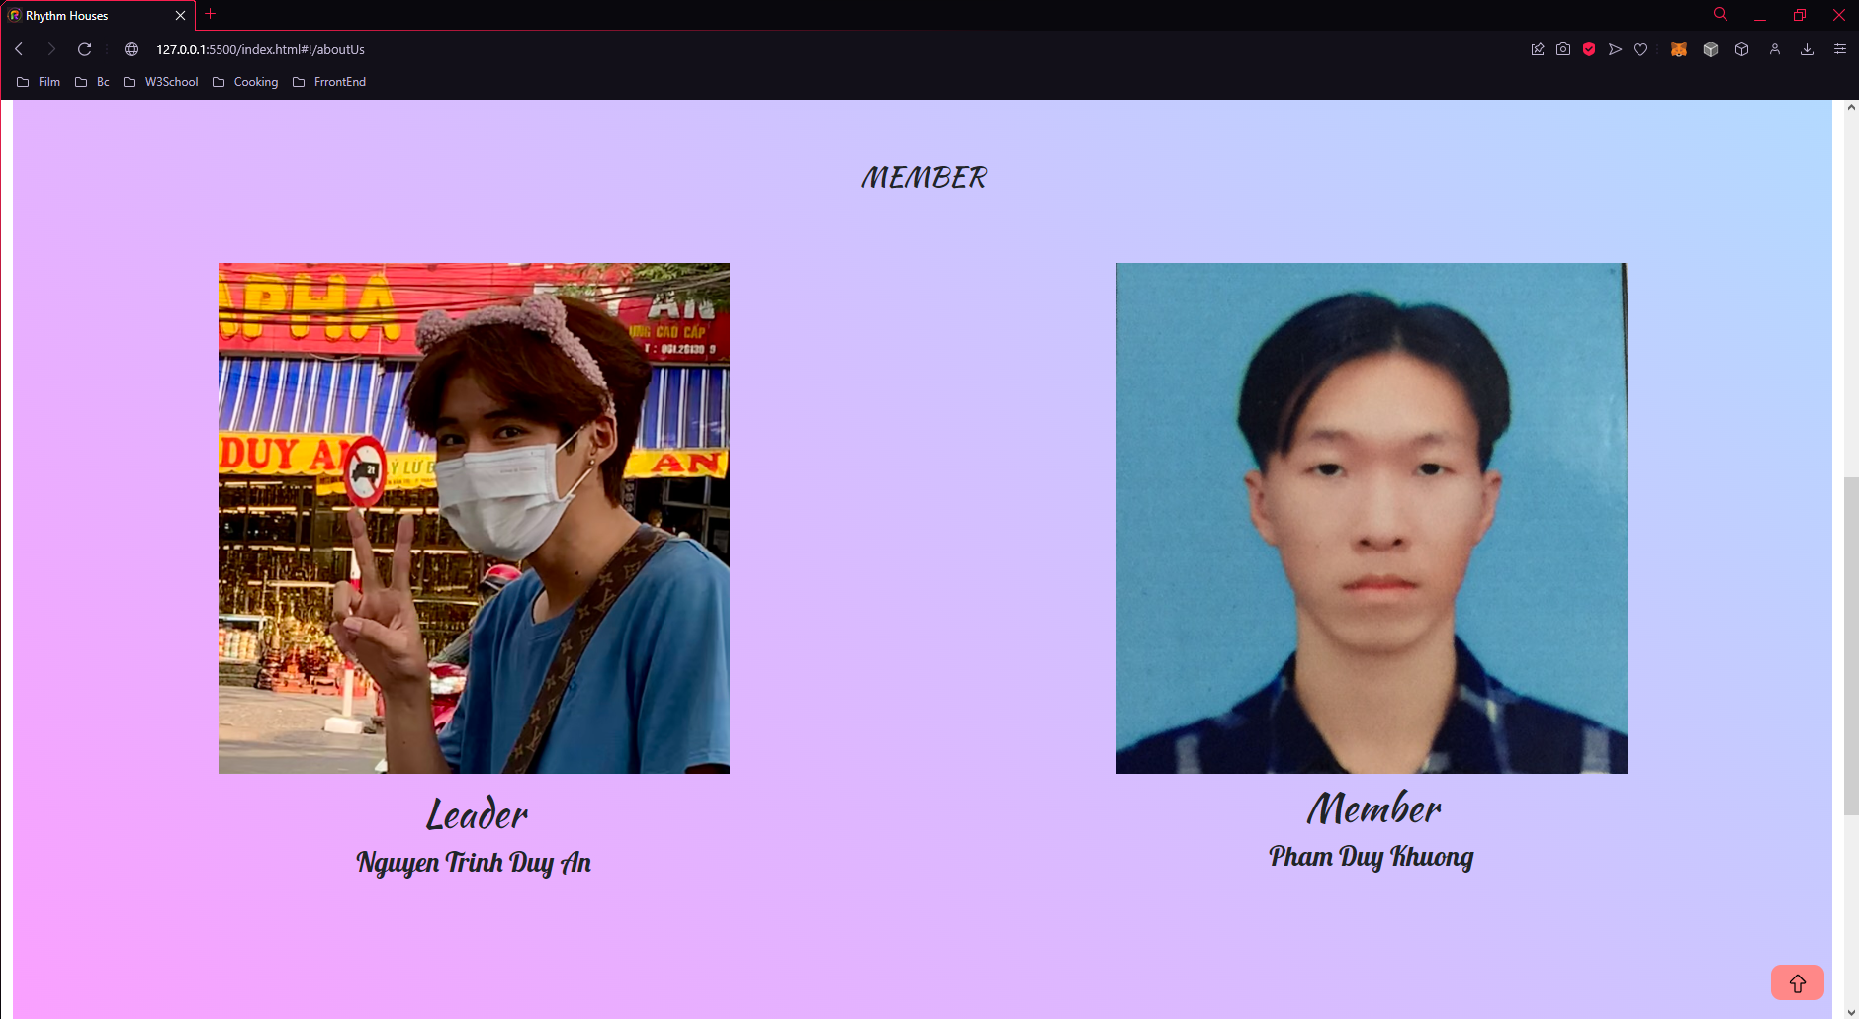

*Figure 6*

1. Contact Us Page

We provide 3 ways to contact us at first, and when you scroll down you can see a map and a form.

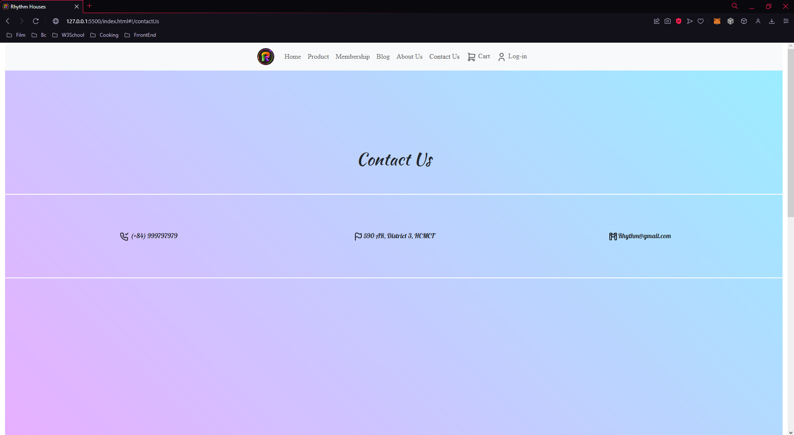

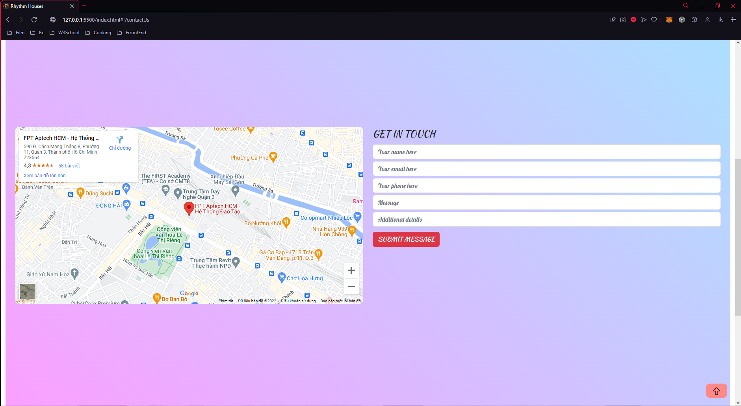

*Figure 7*

1. Cart Page

Cart page will display list of products in your cart (of course there is nothing in case you do not add anything to cart). You can also plus, minus quantity or remove product from cart. And then you can order, but remember to fill in the form!

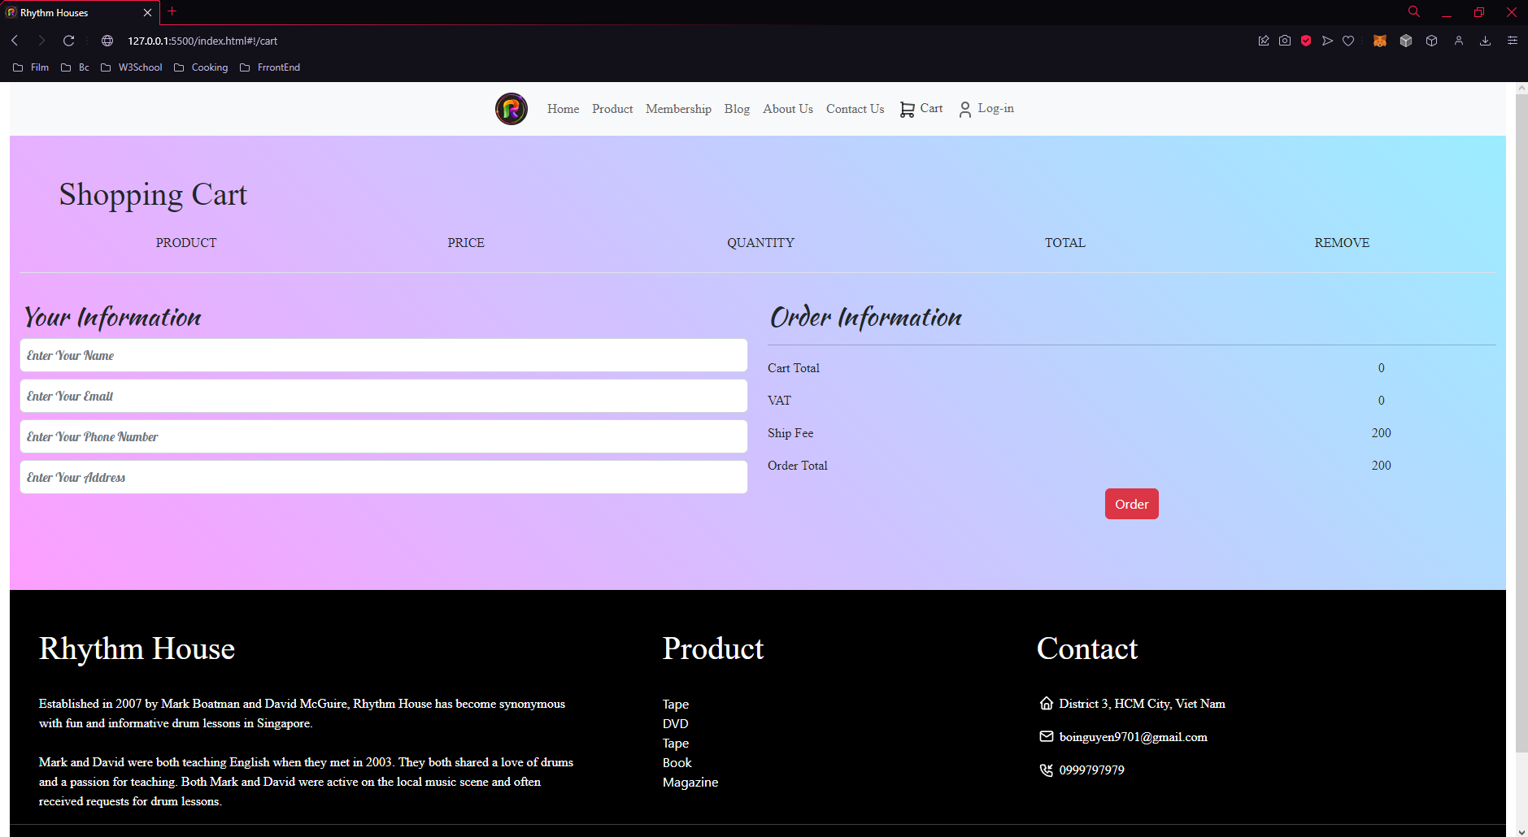

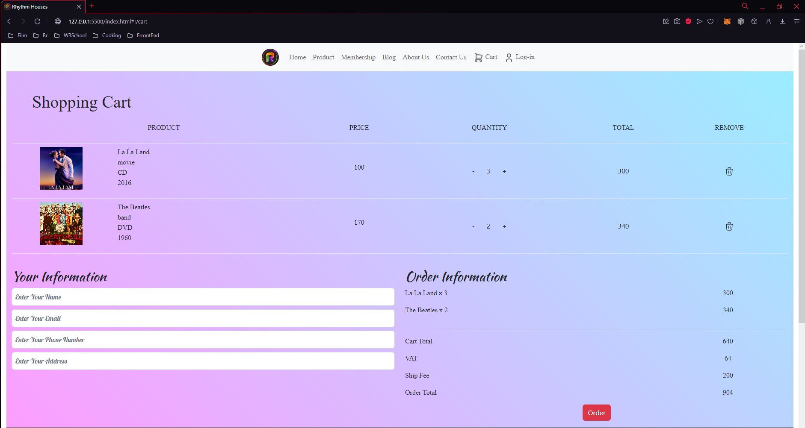

*Figure 8*

1. Log-in Page

Sign-up, log-in and log-out service are ready. Try our website for now!

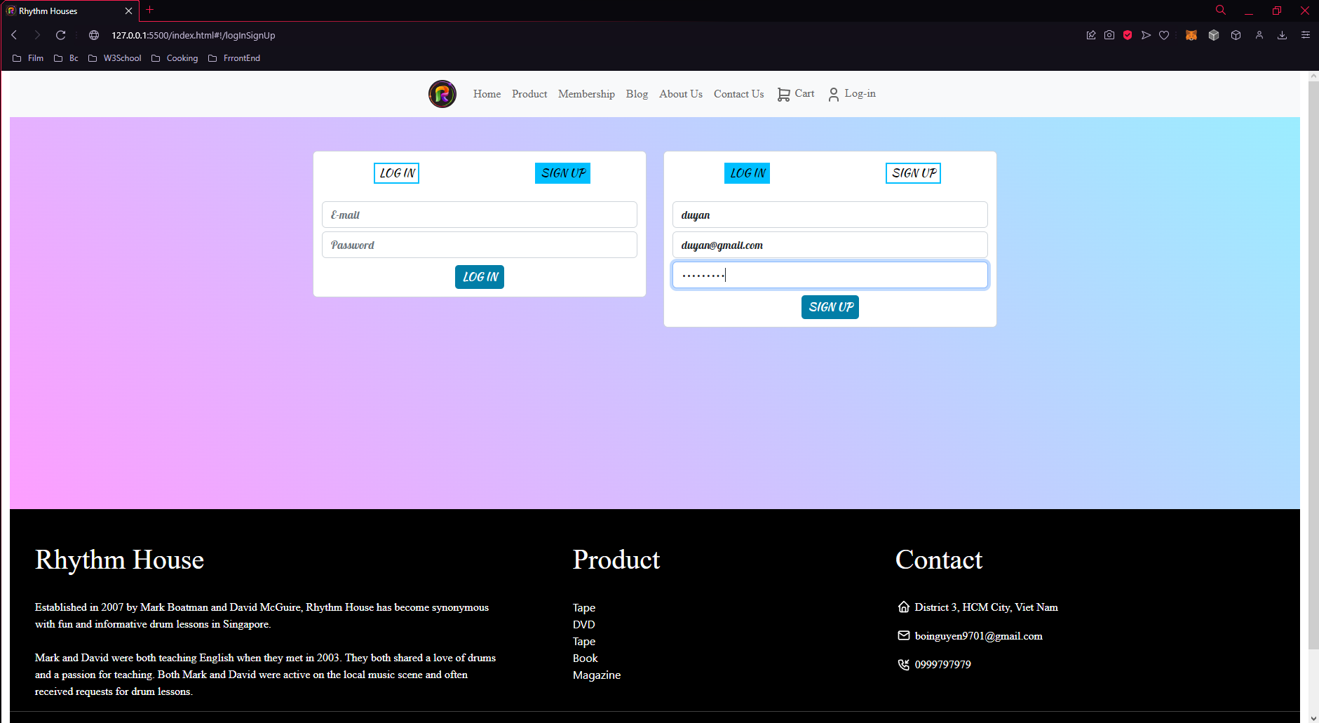 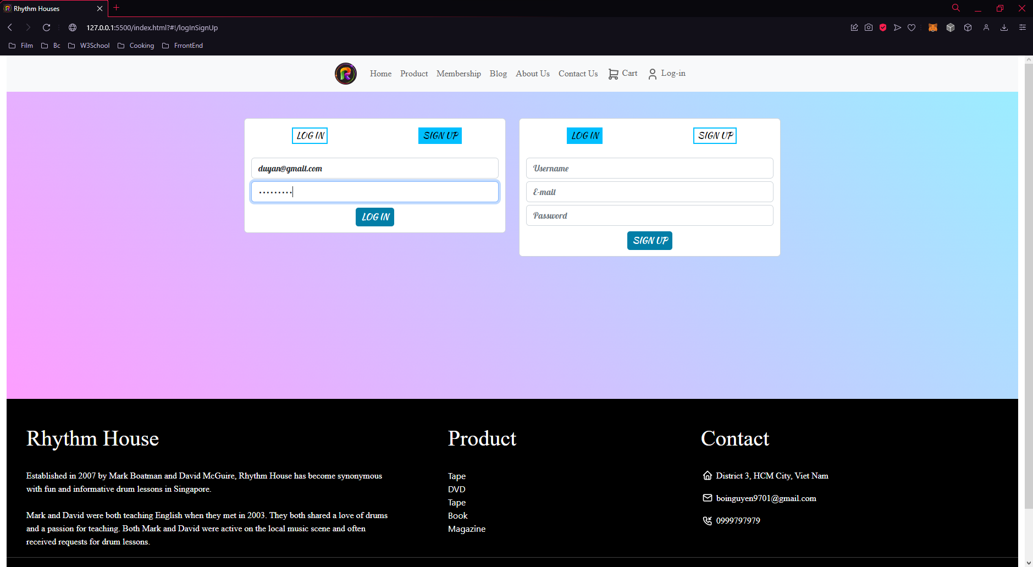

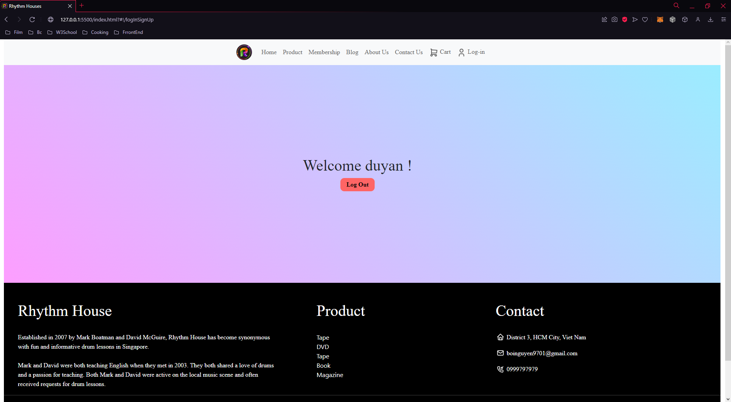

*Figure 9*

*And don’t forget that there is a automatically-scroll-up-to-top button at bottom-right if you has gone too deep 😊

